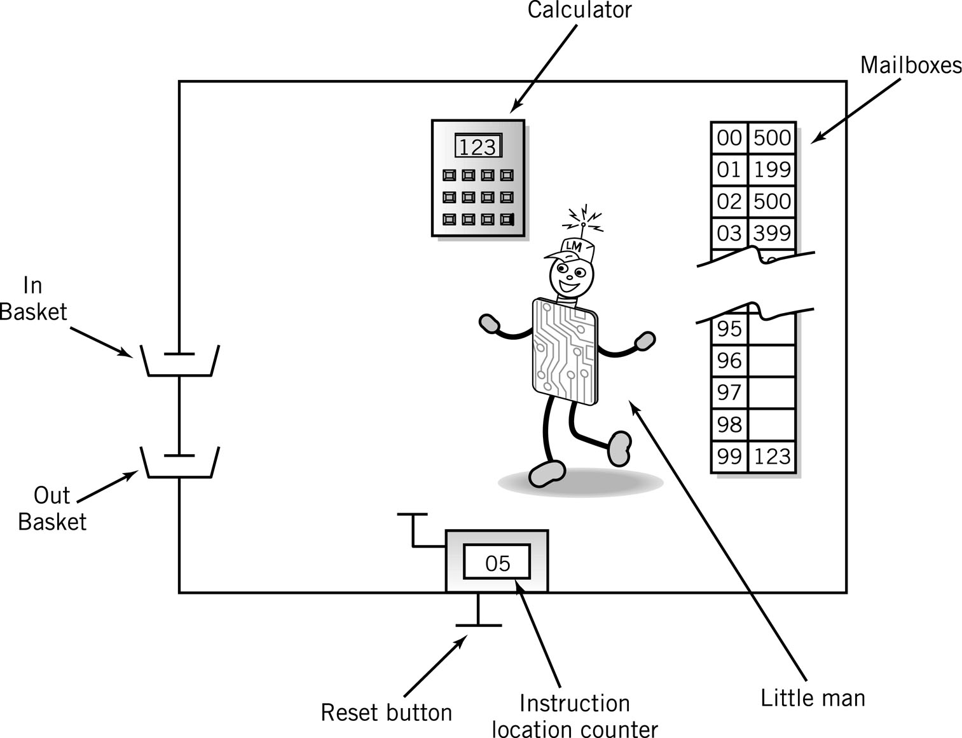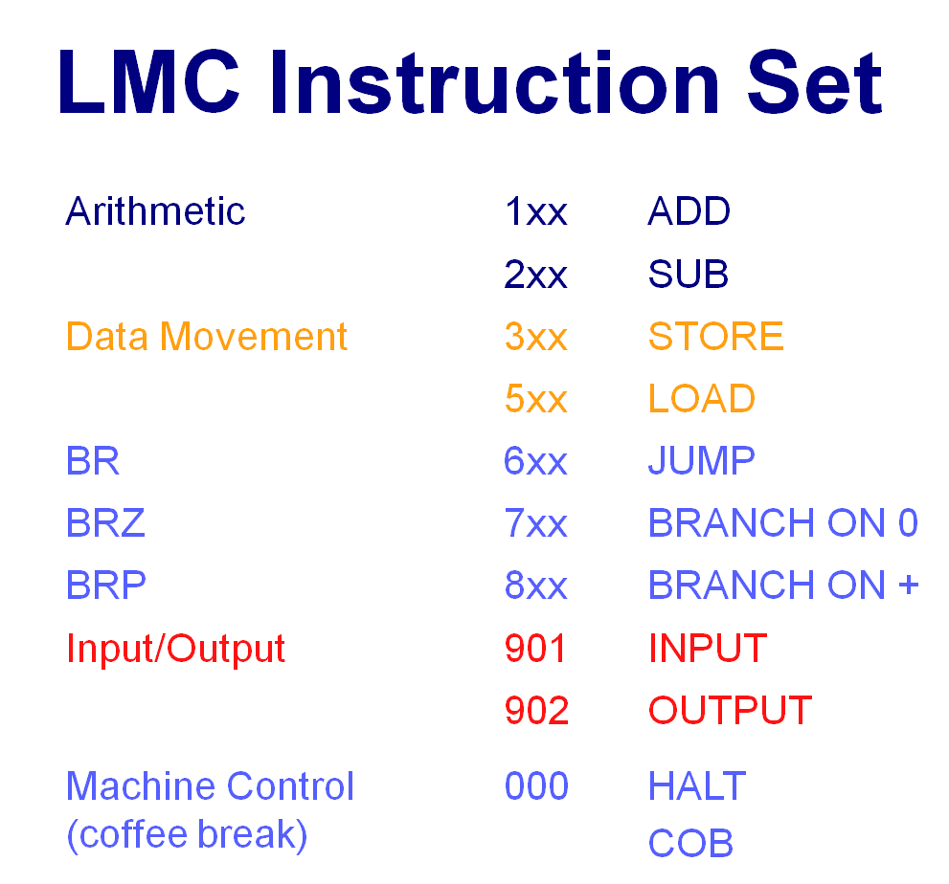
Using the Little Man Computer and Instruction Set, answer the following questions:

- Write a LMC program, which takes 2 input values, say A and B, and then outputs all integers between these two values. (Note: There are two possible cases: A ≤ B, or A > B, you need to write the program that is capable of handling both cases. For the integers between A and B, however, your program can output in either ascending or descending order. )

- Create a LMC program to output the first N Fibonacci numbers. Your program should take the input N and then output the first N elements of the sequence. i.e. 1, 1, 2, 3, 5… (Definition of Fibonacci numbers can be found at https://en.wikipedia.org/wiki/Fibonacci_number)

